What is Head & Neck Cancer

Head and neck cancer describes cancers within this area, where cancer starts in the tissues in the head and neck area.
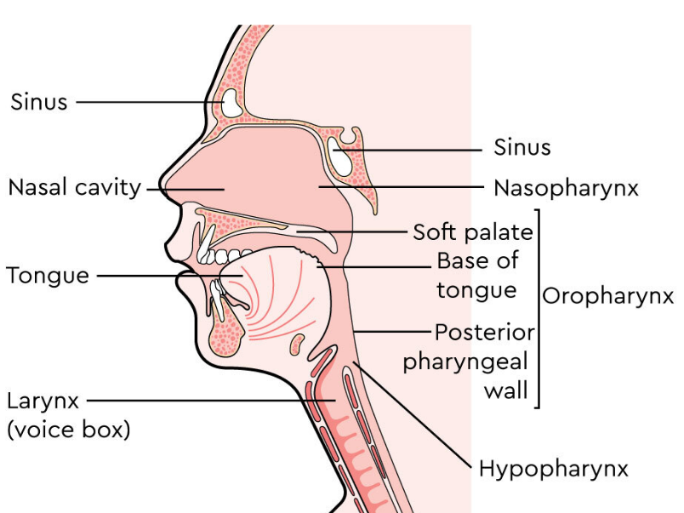
For example:
- mouth which includes the tongue, palate, gums and lips
- throat (the pharynx) which is divided into the nasopharynx, oropharynx and hypopharynx
- nose and sinuses (air-filled spaces in the bones of the face)
- salivary glands which make saliva
- middle ear which contains the ear drum.

