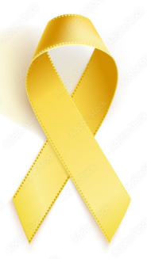
What is sarcoma?

Sarcomas are rare cancers. There are 2 main types of sarcoma:
- Soft tissue sarcoma
- Bone sarcoma (also called primary bone cancer)

The sarcoma UK Support Line is here for every person affected by sarcoma.
*Call them on 08088010401.
**Email supportline@sarcoma.org.uk.
***Text 07860058830.

